**HOUSEHUNT – A HOUSE RENT APP USING MERN**

**A PROJECT REPORT**

***Submitted by***

**Aditi Singh**

**Nitya Santosh**

**Samradhi Sharma**

**Ruturaj Bhoite**

**TEAM ID: SWTID1743517551**



**SCHOOL OF COMPUTING SCIENCE AND ARTIFICIAL INTELLIGENCE**

**VIT BHOPAL UNIVERSITY**

**KOTHRIKALAN, SEHORE**

**MADHYA PRADESH - 466114**

APRIL 2025

**TABLE OF CONTENTS**

|  |  |  |
| --- | --- | --- |
| **CHAPTER NO.** | **TITLE** | **PAGE NO.** |
| 1. | **Introduction:**   * 1. Project Overview   2. Purpose |  |
| 2. | **Ideation Phase**   * 1. Problem Statement   2. Empathy Map Canvas   3. Brainstorming |  |
| 3. | **Requirement Analysis**   * 1. Customer Journey map   2. Solution Requirement   3. Data Flow Diagram   4. Technology Stack |  |
| 4. | **Project Design**   * 1. Problem Solution Fit   2. Proposed Solution   3. Solution Architecture |  |
| 5. | **Project Planning and Scheduling**   * 1. Project Planning |  |
| 6. | **Functional and performance testing:**   * 1. Performance Testing |  |
| 7. | **Results**  7.1 Output Screenshots |  |
| 8. | **Advantages & disadvantages** |  |
| 9. | **Conclusion** |  |
| 10. | **Future scope** |  |
| 11. | **Appendix**  GitHub & Project Demo Link |  |

**CHAPTER -1: INTRODUCTION**

**1.1 Project Overview**

**HouseHunt** is a MERN (MongoDB, Express.js, React.js, Node.js) stack-based full-stack web application designed to revolutionize the house renting experience. The platform aims to bridge the gap between property owners and potential tenants by offering a seamless, transparent, and interactive digital solution. Users can register either as property owners to list their rental homes or as tenants to explore available options, make bookings, and manage their rental journey entirely online. With a responsive user interface, interactive map integration, secure authentication, and features like property reviews and dashboards, HouseHunt delivers an efficient, user-friendly alternative to traditional rental methods.

**1.2 Purpose**

The primary purpose of **HouseHunt** is to simplify and digitize the process of house hunting and property renting. It addresses the challenges faced by both renters and property owners, such as lack of verified listings, inefficient communication, and the need for physical visits. The platform enables tenants to search, filter, and book properties based on their preferences, while allowing owners to manage listings and bookings with ease. By integrating features like booking management, real-time availability, and feedback systems, HouseHunt ensures a trustworthy and convenient rental experience for all users.

**CHAPTER -2: IDEATION PHASE**

**2.1 Problem Statement:**

Finding a rental property in a new city is often a stressful, time-consuming, and inefficient process. Renters struggle with unreliable listings, lack of verified information, and limited communication with property owners. Meanwhile, property owners face difficulties in showcasing their properties effectively and managing bookings and inquiries.

There is a need for a unified digital platform that provides accurate property listings, real-time availability, secure communication, and a seamless booking experience. **HouseHunt** aims to solve these challenges by creating a user-friendly web application that connects renters and property owners directly, ensuring trust, convenience, and transparency in the rental process.

**2.2 Empathy Map Canvas:**

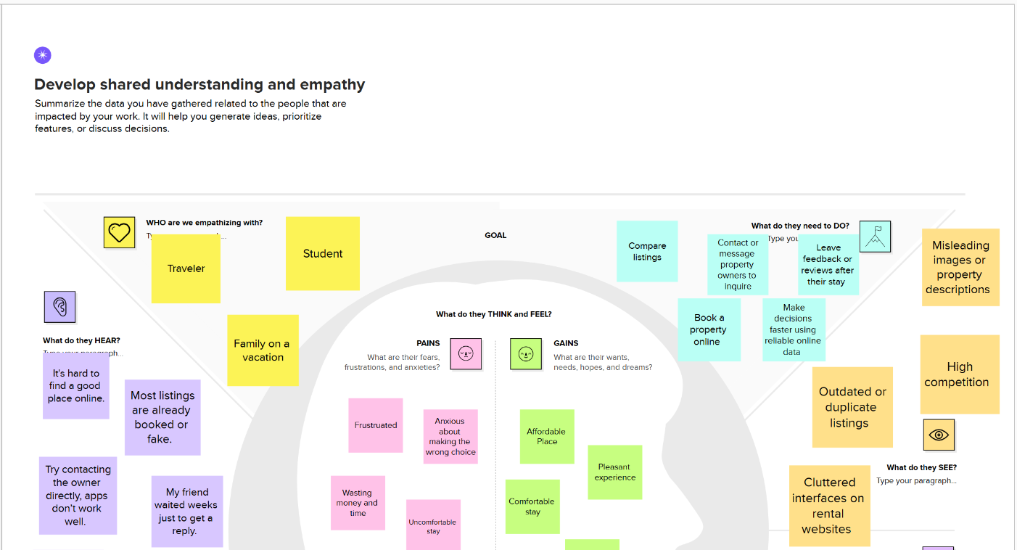

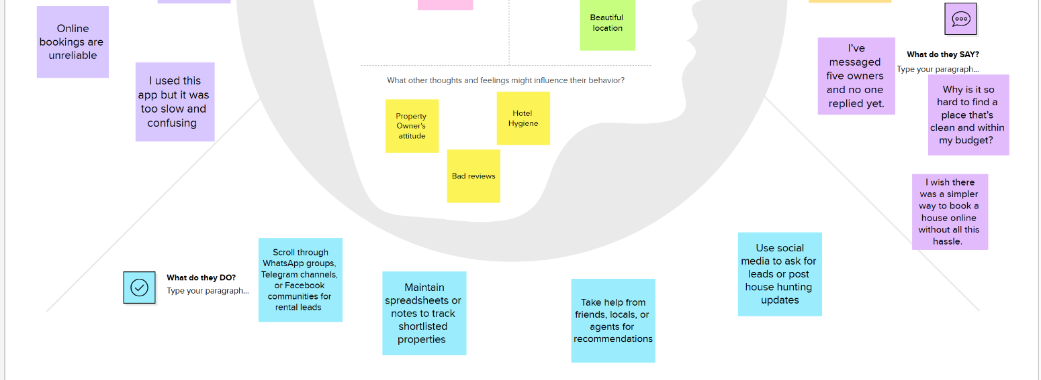

**2.3 Brainstorming:**

The brainstorming process for the **HouseHunt** project began with identifying common pain points in the current house rental experience, both for renters and property owners. Our team of four members collaborated to generate ideas from different technical and user-focused perspectives, contributing insights based on roles such as frontend development, backend architecture, database management, and testing.

Each member proposed multiple features and solutions, which were documented as individual ideas or "sticky notes." These ideas were then grouped into thematic clusters based on common goals—such as improving user experience, ensuring security, optimizing database structure, and enabling efficient communication.

This structured ideation helped us prioritize essential features like secure user authentication, advanced search and filter capabilities, a real-time booking system, interactive dashboards, and property reviews. The outcome of this process was a clear roadmap of features aligned with user needs and technical feasibility, forming the foundation of the HouseHunt platform.

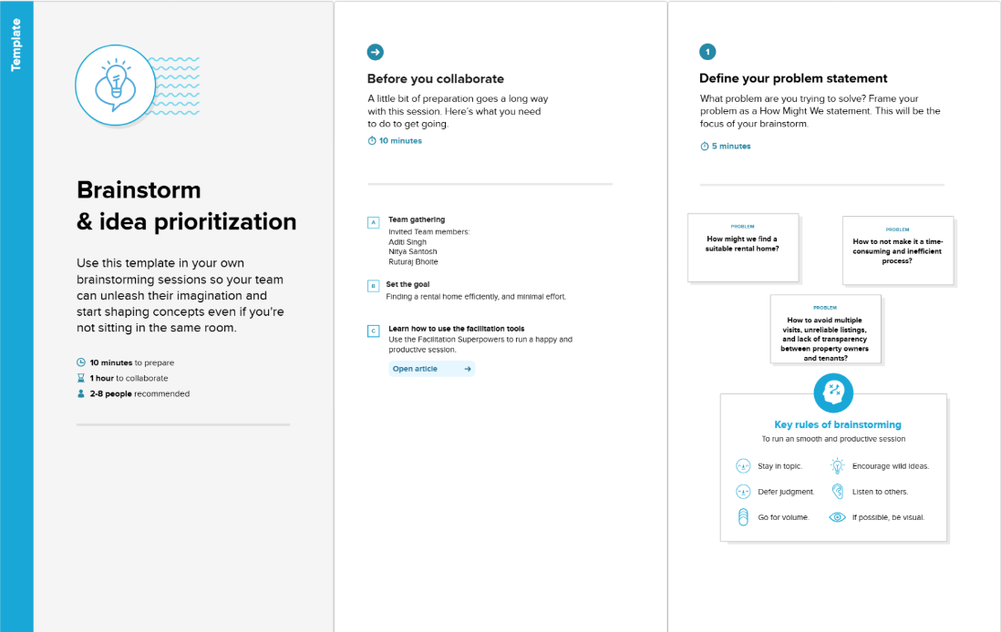

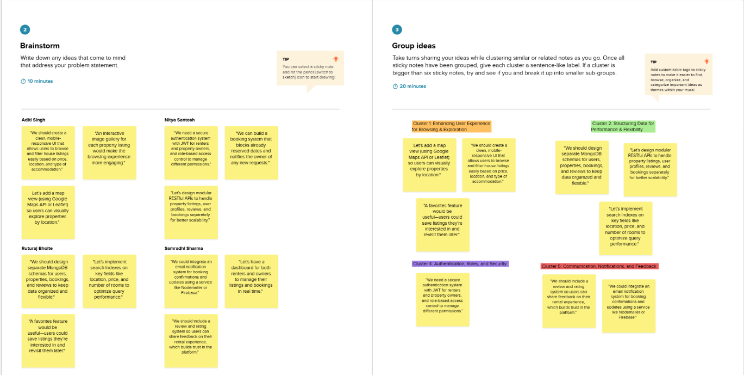

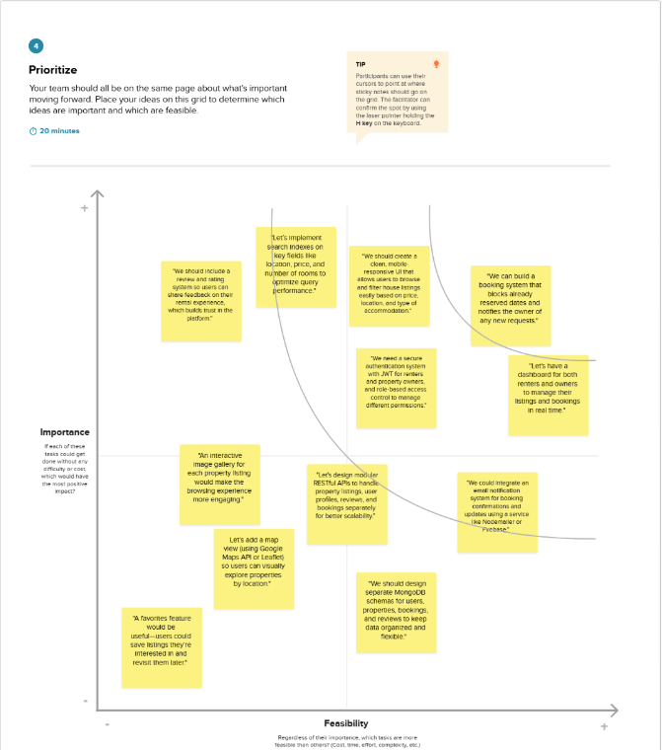

**CHAPTER -3: REQUIREMENT ANALYSIS**

**3.1 Customer Journey map:**

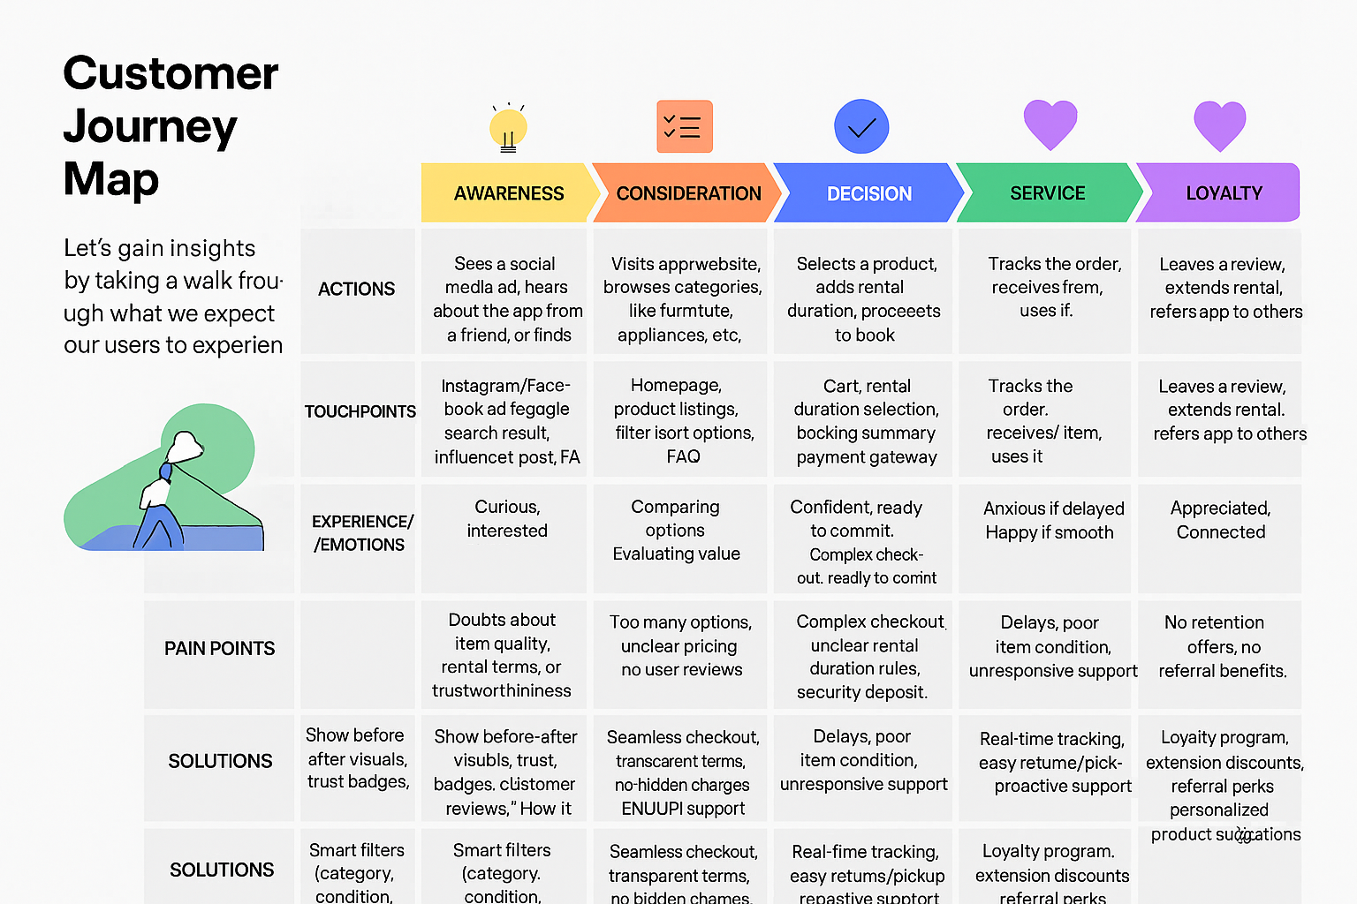

**3.2 Solution Requirement:**

**Functional Requirements:**

Following are the functional requirements of the proposed solution.

|  |  |  |
| --- | --- | --- |
| **FR No** | **Functional Requirement (Epic)** | **Sub Requirement (Story / Sub-Task)** |
| **FR-1** | User Registration | Registration via Form,  Registration via Form Gmail,  Registration via Form Facebook |
| **FR-2** | User Confirmation | Email and OTP confirmation |
| **FR-3** | User Login | Login via Form or Social Media |
| **FR-4** | House Discovery | Browse by Type/Location,  Filter by Rent/Rating |
| **FR-5** | House Details Viewing | View House Info (price, location, images) |
| **FR-6** | Booking Management | Add/Remove Bookings,  View Summary |
| **FR-7** | Booking Placement | Select Dates, Payment Mode,  Confirm Booking |
| **FR-8** | Booking Tracking | View Booking Status,  Live Status Updates |
| **FR-9** | Booking History | View Past Bookings,  Repeat Bookings |
| **FR-10** | Ratings and Reviews | Rate Owners/Houses,  Write Reviews |

**Non-functional Requirements:**

Following are the non-functional requirements of the proposed solution.

|  |  |  |
| --- | --- | --- |
| **FR No.** | **Non-Functional Requirement** | **Description** |
| NFR-1 | **Usability** | The UI should be intuitive, responsive, and accessible on both web and mobile. Filters (location, budget, property type), clear icons, and an easy booking flow should be provided to improve user experience. |
| NFR-2 | **Security** | Secure user data and transactions using SSL/TLS encryption. Use secure login (OAuth2/JWT), validate user identity during booking, and follow GDPR for personal data handling. |
| NFR-3 | **Reliability** | The platform should handle high volumes of booking requests without errors. Automatic backup and recovery of booking and user data should be ensured. Integrity checks must be in place for payment and transaction logs. |
| NFR-4 | **Performance** | Webpages and search results should load within 2 seconds. Implement caching (e.g., Redis), compress images, and optimize database queries to ensure fast performance. |
| NFR-5 | **Availability** | Ensure 99.9% uptime using cloud infrastructure, autoscaling, load balancers, and redundancy for critical services like booking and payment APIs. |
| NFR-6 | **Scalability** | |  | | --- | |  |  |  | | --- | | The system must scale to support high traffic during  peak seasons (e.g., festivals, relocation periods). Use microservices, containerization, and load balancing to manage increased demand. | |

**3.3 Data Flow Diagram:**

**Data Flow Diagrams:**

A Data Flow Diagram (DFD) is a traditional visual representation of the information flows within a system. A neat and clear DFD can depict the right amount of the system requirement graphically. It shows how data enters and leaves the system, what changes the information, and where data is stored.

**HOUSEHUNT – A HOUSE RENT APP DFDs:**

**Level-0 Description:**

In this diagram, Customer,

Landlords and System Administrator are entity sets.

Functions of Customer:

· New Registration

· Login Request

. Registration Confirmation by the System

· Reserve House

. House Issued by the System

. Email received for Reserved House.

Functions of System Administrator

· Add Customers/Tenants/landlords

· Send E-Mails for Reserved House

· View Transaction reports

. Post Vacant Houses

Functions of Landlord:

· Register in the system

· Post a New house

· Send House Confirmation to System Administrator

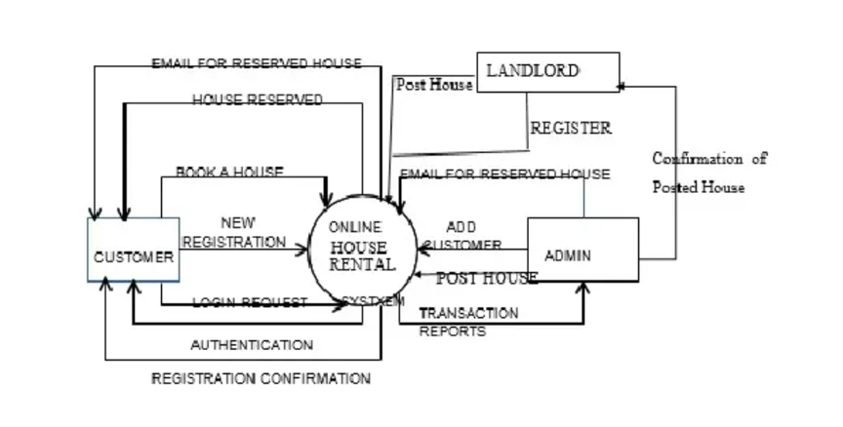

**LEVEL-1 DESCRIPTION:**

#### Customer

* **New Registration**: Customers register themselves as new users in the system.
* **Login Request**: Registered customers log in using their credentials.
* **Registration Confirmation by the System**: After successful registration, the system confirms and stores user details in the Customer DB.
* **Reserve House**: Customers browse available houses, choose a house, and initiate the rental process.
* **House Issued by the System**: Upon confirmation, the system reserves the selected house for the customer.
* **Email Received for Reserved House**: The customer receives an email confirmation for the reserved house.
* **Return & Feedback**: Customers can return the rented house and submit feedback.

#### Landlord

* **Register in the System**: Landlords register and log in to the system.
* **Post a New House**: Landlords can add details about new houses for rent.
* **Send House Confirmation to System Administrator**: Upon posting, confirmation is sent to the admin for review and listing.

#### System Administrator

* **Add Customers/Tenants/Landlords**: Admin has the authority to add and manage user profiles including customers and landlords.
* **Send E-Mails for Reserved House**: Admin sends out confirmation emails for house reservations.
* **View Transaction Reports**: Admin can view reports from Customer DB, Landlord DB, and House DB.
* **Post Vacant Houses**: Admin can approve and post new house listings submitted by landlords.

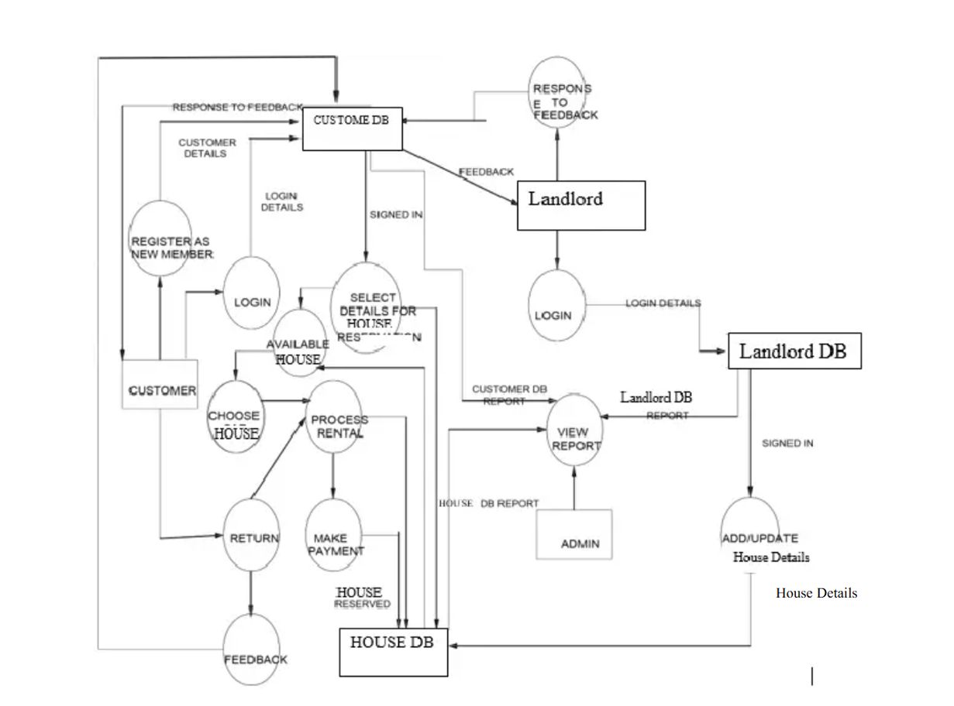

**3.4 Technology Stack:**

**Technical Architecture:**

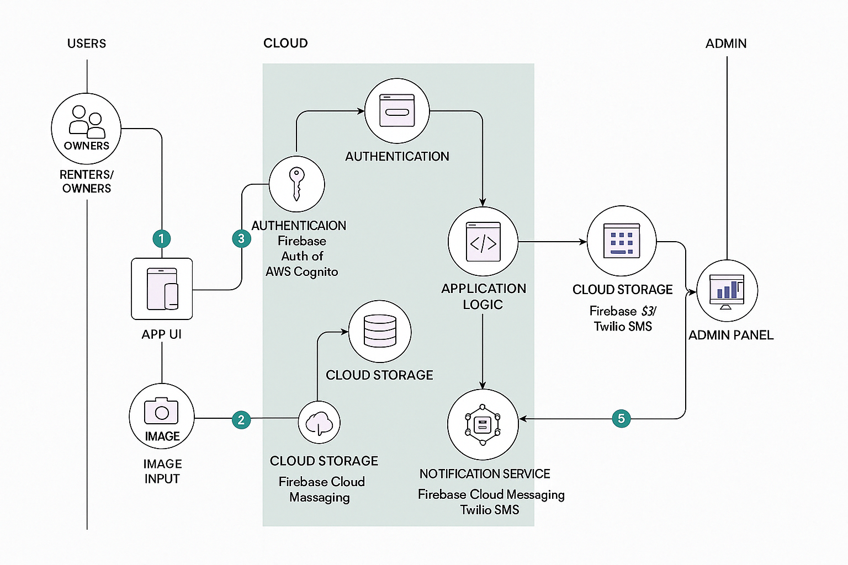

|  |  |  |  |
| --- | --- | --- | --- |
| **S.No** | **Component** | **Description** | **Technology** |
| 1 | User Interface | How users browse listings, filters, book houses | HTML, CSS, JavaScript, React.js |
| 2 | Application Logic-1 | Handles user authentication, session, and role management | Node.js / Express.js |
| 3 | Application Logic-2 | Listing management, booking logic, payment flow | Node.js / Express.js |
| 4 | Database | Stores user data, listings, reviews, payment logs | MongoDB |
| 5 | Cloud Database | Scalable cloud-based storage for listings and transactions | Firebase / Amazon RDS |
| 6 | File Storage | Stores images of rental houses and user-uploaded documents | Firebase Storage / Local Filesystem |
| 7 | External API-1 | Address autocomplete, map embedding, rental price suggestions | Google Maps API / OpenStreetMap / RentCast |
| 8 | Infrastructure (Server/Cloud) | Hosting, scaling, and deployment of the app | Vercel / Heroku / AWS / Render |
| 9 | Notifications | Sends email/SMS/Push alerts for booking updates and reminders | Firebase Cloud Messaging / Twilio / SendGrid |
| 10 | Analytics | Tracks user behavior, engagement, and app performance | Google Analytics / Mixpanel |
| 11 | Admin Dashboard | Manages listings, users, payments, reviews and issues | React.js / Node.js / MongoDB |

**Table-2: Application Characteristics:**

| **S.No** | **Characteristics** | **Description** | **Technology** |
| --- | --- | --- | --- |
|  | Open-Source Frameworks | The app utilizes open-source tools for development, enabling transparency, community support, and cost-efficiency. | React Native (Frontend), Node.js (Backend) |
|  | Security Implementations | App includes role-based access, secure login with JWT, HTTPS encryption, and server-side input validation to prevent data breaches. | JWT, HTTPS, Bcrypt, OWASP Secure Headers |
|  | Scalable Architecture | The architecture follows a modular microservices pattern with decoupled front-end and back-end, allowing horizontal scaling when needed. | Docker, Kubernetes, RESTful APIs |
|  | Availability | Load balancers and cloud-hosted backend ensure high availability and minimal downtime for users searching for or listing rental properties. | NGINX, AWS Elastic Load Balancer |
|  | Performance | Optimized for fast response time using caching, asynchronous APIs, and content delivery networks (CDNs) for static assets. | Redis Cache, Cloudflare CDN, Lazy Loading in React |

**CHAPTER -4: PROJECT DESIGN**

**4.1 Problem Solution Fit:**

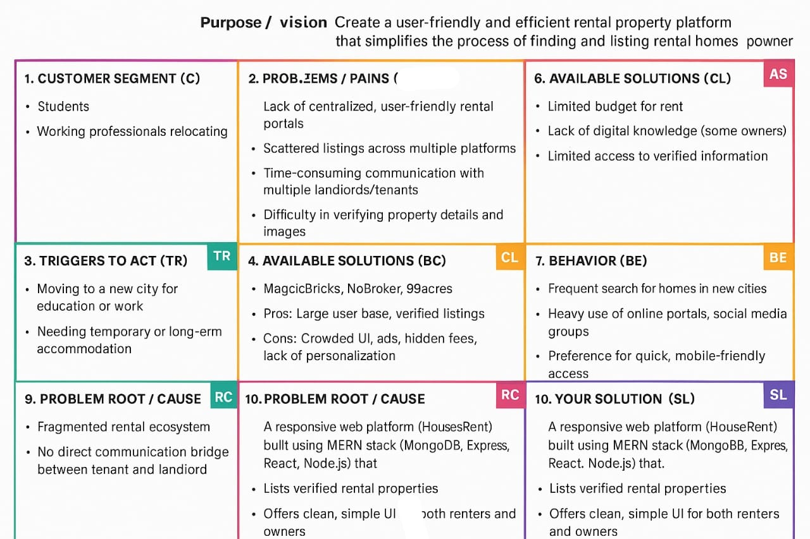

**4.2 Proposed Solution:**

|  |  |  |
| --- | --- | --- |
| **S.No.** | **Parameter** | **Description** |
|  | Problem Statement (Problem to be solved) | Finding affordable rental homes with verified listings, transparent processes, and secure interactions remains a major challenge for students and working individuals. Landlords also face issues with visibility and tenant verification |
|  | Idea / Solution description | HouseRent is an AI-integrated web platform that allows users to list, browse, and book rental properties easily.  It includes smart search filters, image validation, admin approval, and a secure JWT-based login system. |
|  | Novelty / Uniqueness | Intelligent matching algorithm to show best-fit listings.  Role-based dashboards for tenants, landlords, and admins. |
|  | Social Impact / Customer Satisfaction | Helps to find reliable and verified rental housing. Minimizes scams and misleading listings. Improves trust and accessibility in the rental ecosystem. |
|  | Business Model (Revenue Model) | -Freemium model: Free listings with limited visibility, premium for better reach.  - Featured property promotion.  - Subscription plan for landlords.  - Ad placements and partner property deals. |
|  | Scalability of the Solution | The modular architecture allows future integration with mobile apps, payment gateways, and smart IoT-enabled properties. |

**4.3 Solution Architecture:**

**Solution Architecture:**

Solution architecture is a comprehensive framework that bridges the gap between the business requirements and the technological implementation of a solution.

**Objectives of Solution Architecture:**

* Identify and implement the best-fit **technology stack** to solve specific business challenges (e.g., housing rental, landlord-tenant interaction).
* Describe the **system structure, data flow**, behavior, and interaction between different modules and services.
* Define **key features**, **phases of development**, and **technical requirements**.
* Provide a scalable and modular architecture that ensures maintainability and performance.

**Tech Stack Used**

|  |  |  |
| --- | --- | --- |
| **Layer** |  | **Technology Used** |
| Frontend |  | React.js (with Axios, React Router) |
| Backend |  | Node.js + Express.js |
| Database |  | MongoDB (NoSQL) |
| Authentication |  | JWT (JSON Web Token) |
| Deployment |  | (Optional: Netlify/Vercel & Render) |
| Tools |  | Postman, VS Code, GitHub |

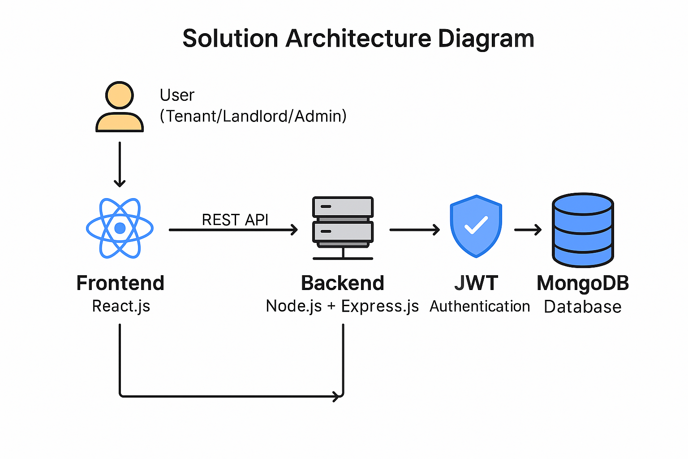

**CHAPTER -5: PROJECT PLANNING & SCHEDULING**

**5.1 Project Planning:**

| **Sprint** | **Functional Requirement (Epic)** | **User Story Number** | **User Story / Task** | **Story Points** | **Priority** | **Team Members** |
| --- | --- | --- | --- | --- | --- | --- |
| Sprint-1 | User Authentication | USN-1 | As a user, I can register and log in to the application using email & password. | 2 | High | Aditi, Nitya |
| Sprint-1 | Property Listing | USN-2 | As a landlord, I can list my property with details and images. | 3 | High | Samradhi,Aditi |
| Sprint-2 | Admin Control | USN-3 | As an admin, I can approve or reject property listings. | 2 | Medium | Ruturaj,Nitya |
| Sprint-2 | Dashboard | USN-4 | As a user, I can view a dashboard showing relevant property listings and my interactions. | 3 | High | Samradhi, Nitya |
| Sprint-3 | Property Filtering | USN-5 | As a user, I can filter properties based on location, rent, and availability. | 2 | Medium | Aditi,Ruturaj |
| Sprint-3 | JWT Authentication | USN-6 | As a user, I can securely log in using JWT so that my session remains authenticated. | 2 | High | Samradhi,Ruturaj |
| Sprint-4 | Role-Based Dashboard | USN-7 | As a user/admin/landlord, I can see a personalized dashboard depending on my role. | 3 | High | Samradhi,Ruturaj,Nitya,Aditi |

**CHAPTER -6: FUNCTIONAL AND PERFORMANCE TESTING**

**6.1 Performance Testing**

**Project Overview:**

Project Name: HOUSEHUNT – A HOUSE RENT APP

Project Description: HouseHunt is a full-stack MERN web application that provides a seamless platform for users to search, list, and rent residential properties online. The platform connects renters with property owners, supports real-time booking, and includes features like user dashboards, map views, and a review system to enhance user trust and experience.

Project Version: 1.0.0

Testing Period: 01.04.2025 to 10.04.2025​

**Testing Scope:**

**Features and Functionalities to be Tested:**

* User Registration and Login
* Property Listing and Management
* Search and Filter Functionality
* Booking System
* Dashboard and Booking History
* Reviews and Ratings

**User Stories or Requirements to be Tested:**

* As a renter, I want to register and log in securely.
* As a property owner, I want to list a house with complete details.
* As a renter, I want to search and filter properties by location, price, and type.
* As a renter, I want to book a property and get confirmation.
* As a user, I want to see my booking history in a personal dashboard.
* As a renter, I want to leave reviews and rate the property after staying.

**Test Cases:**

|  |  |  |  |  |  |
| --- | --- | --- | --- | --- | --- |
| **Test Case ID** | **Test Scenario** | **Test Steps** | **Expected Result** | **Actual Result** | **Pass/Fail** |
| TC-001 | User Registration | 1. Navigate to registration page 2. Enter valid details 3. Submit form | User account is created with confirmation message | As Expected | Pass |
| TC-002 | User Login | 1. Navigate to login 2. Enter credentials 3. Click login | User is logged in and redirected to their dashboard | As Expected | Pass |
| TC-003 | Add Property Listing | 1. Log in as owner 2. Navigate to "Add Property" 3. Enter details 4. Submit | Listing is saved and shown in "My Listings" | As Expected | Pass |
| TC-004 | Property Search & Filter | 1. Navigate to search page 2. Apply filters 3. Browse listings | Listings are filtered and displayed based on criteria | As Expected | Pass |
| TC-005 | Book a Property | 1. Log in as renter 2. View listing 3. Choose dates 4. Confirm booking | Booking confirmation shown, calendar updated | As Expected | Pass |
| TC-006 | View Dashboard | 1. Log in 2. Navigate to dashboard | Displays current and past bookings/listings with visual elements | As Expected | Pass |
| TC-007 | Add Review | 1. Complete stay 2. Navigate to property 3. Submit rating and review | Review appears publicly under the property profile | As Expected | Pass |

**Bug Tracking:**

|  |  |  |  |  |  |
| --- | --- | --- | --- | --- | --- |
| **Bug ID** | **Bug Description** | **Steps to Reproduce** | **Severity** | **Status** | **Additional Feedback** |
| BG-001 | Booking calendar not updating | 1. Book property 2. Revisit listing calendar | High | Resolved | Calendar did not reflect booked dates initially |
| BG-002 | Filter not resetting properly | 1. Apply filters 2. Click “Reset” | Medium | In Progress | UI bug; filters persist even after reset is clicked |
| BG-003 | Dashboard slow to load | 1. Log in 2. Go to dashboard | Low | Open | May need pagination or data optimization |

**Sign-off:**

**Tester Name:** Samradhi Sharma  
**Date:** 11.04.2025

**CHAPTER -7: RESULTS**

**7.1 Output Screenshots:**



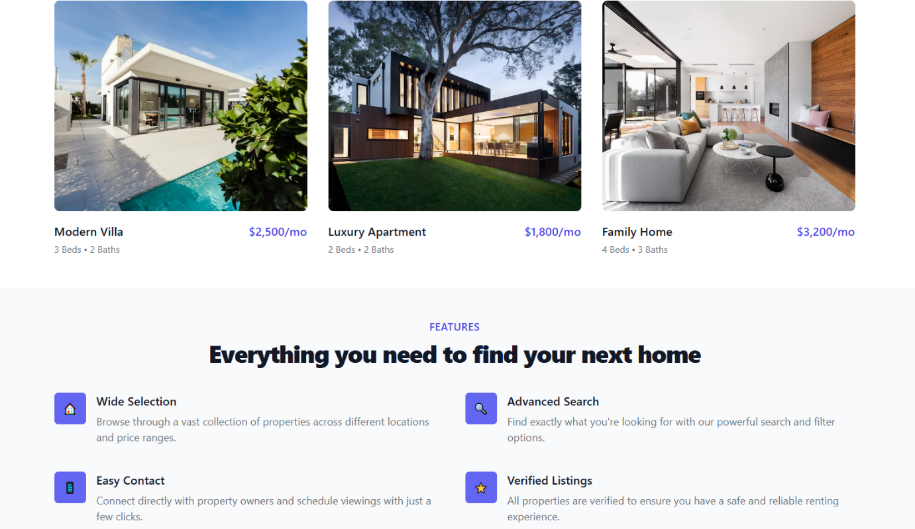

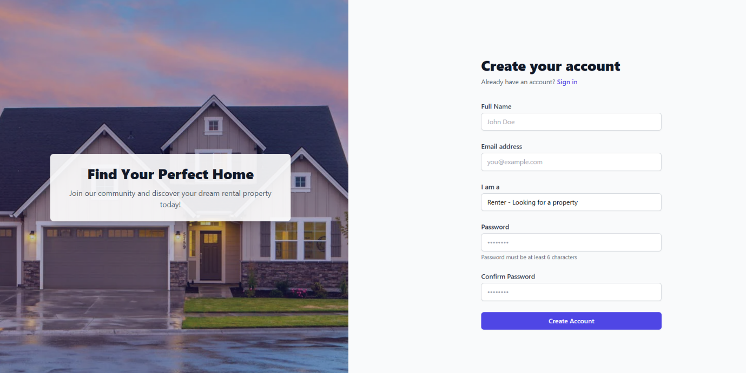

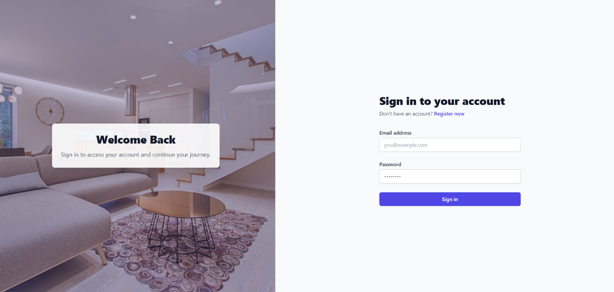

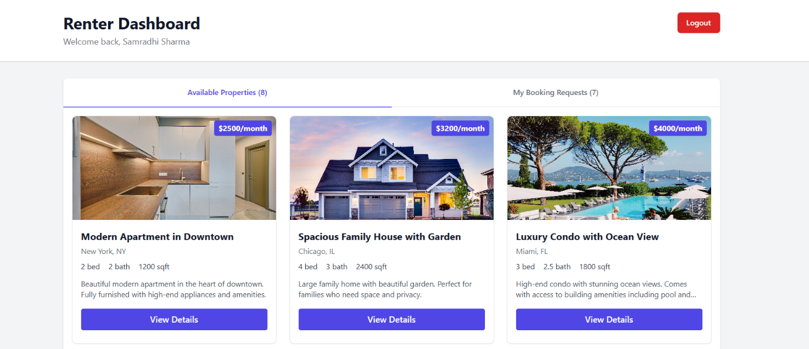

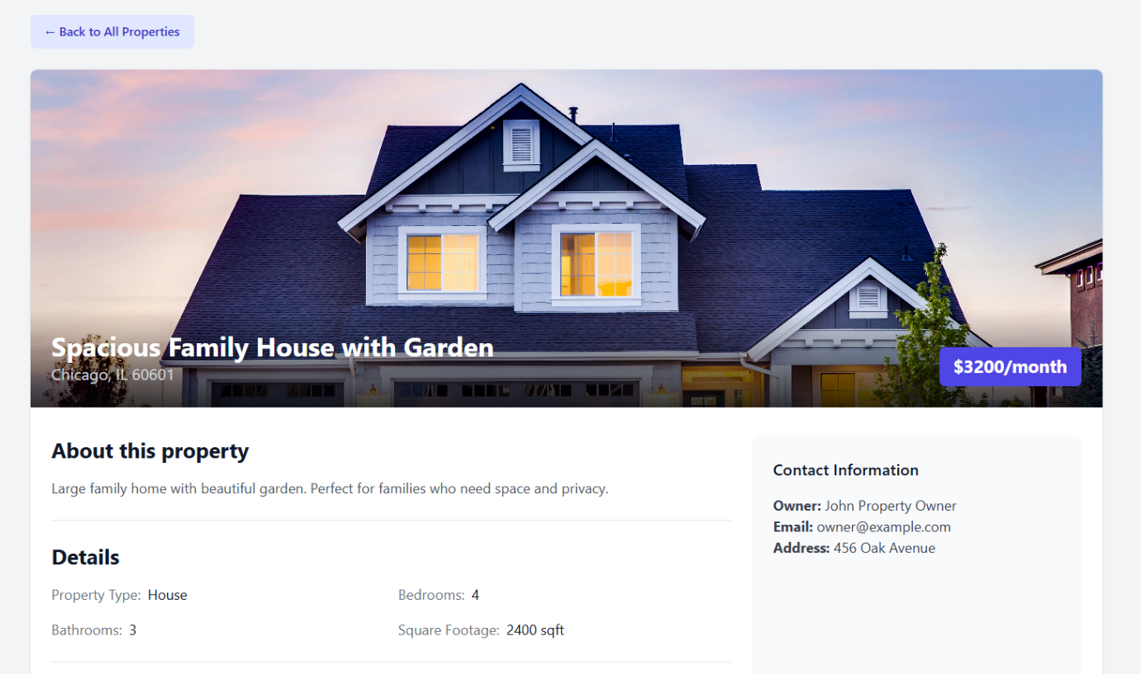

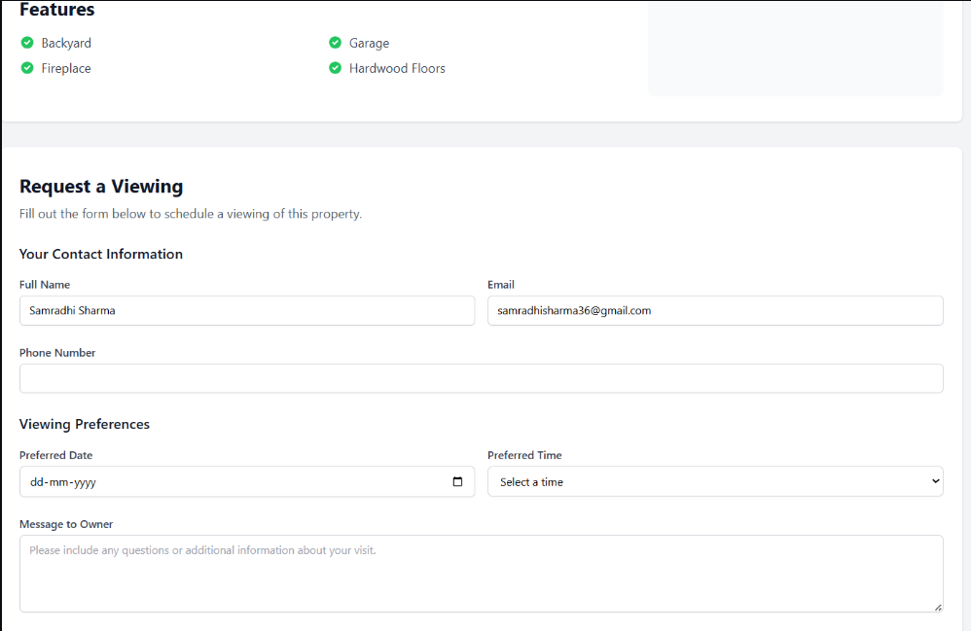

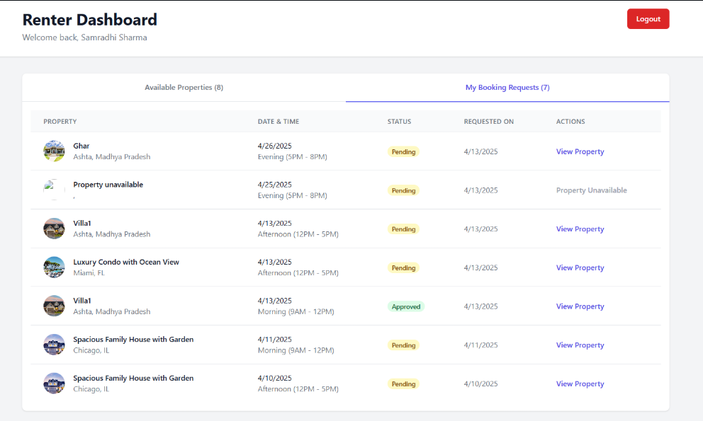

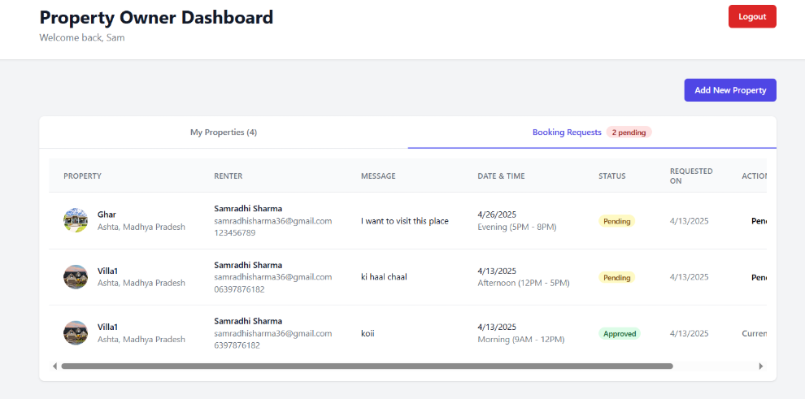

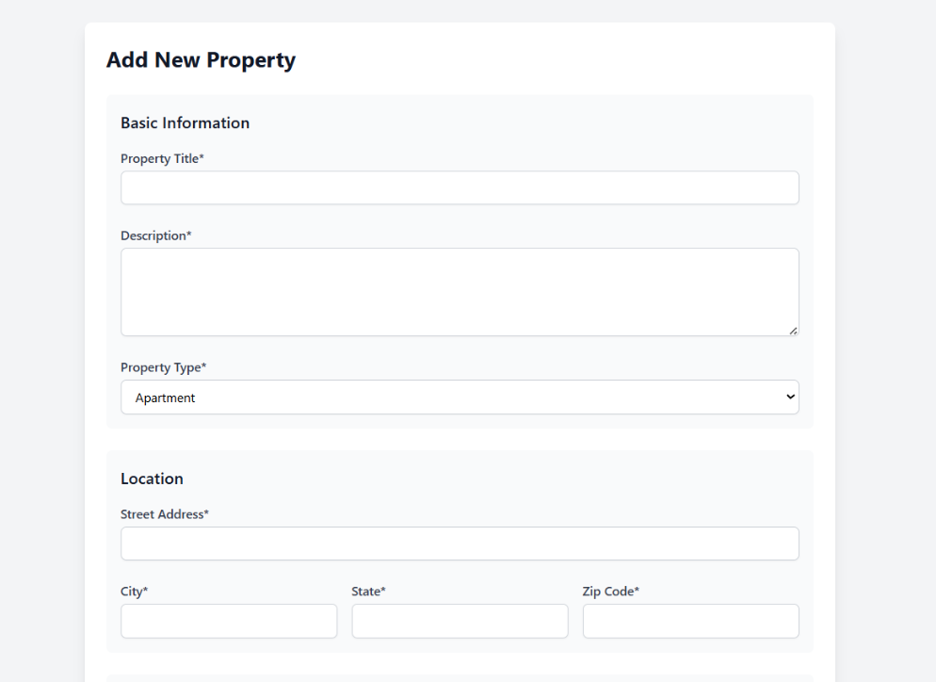

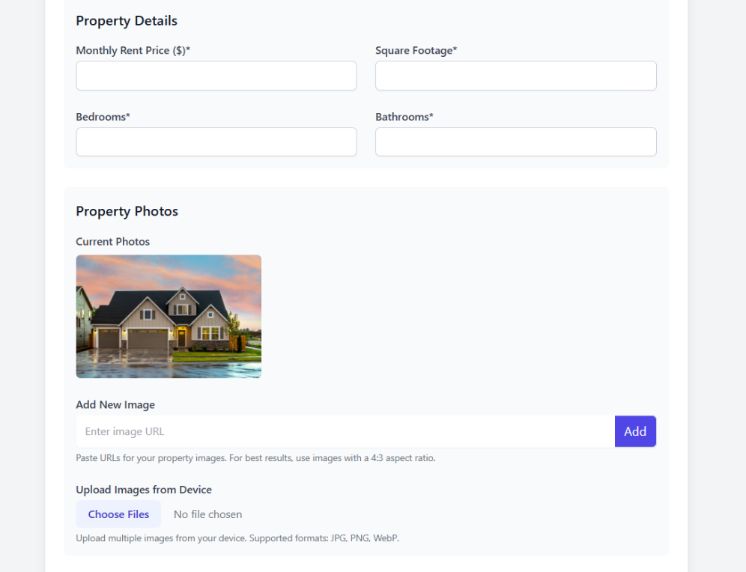

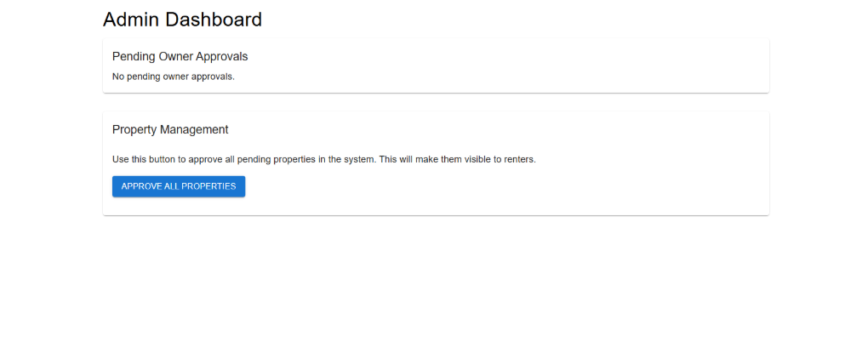

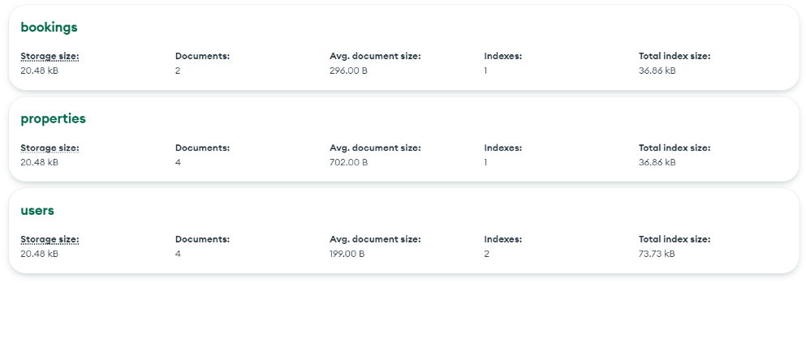

**CHAPTER -8: ADVANTAGES & DISADVANTAGES**

**Advantages**

1. **User-Friendly Interface:**  
   HouseHunt offers a clean and intuitive UI that ensures a seamless browsing and booking experience for both renters and property owners. The responsive design makes it accessible across all devices.
2. **Direct Owner-Renter Interaction:**  
   The platform eliminates the need for middlemen or brokers, allowing direct communication between tenants and property owners, resulting in faster decisions and cost savings.
3. **Real-Time Booking System:**  
   Renters can view real-time availability of properties and make instant bookings, reducing delays and improving transparency in the rental process.
4. **Advanced Search and Filters:**  
   Users can efficiently search for properties using filters such as location, price range, number of rooms, and amenities, enhancing their ability to find suitable homes quickly.
5. **Secure Authentication & Data Privacy:**  
   With JWT-based authentication and role-based access control, HouseHunt ensures secure user sessions and protects sensitive user data.
6. **Interactive Dashboards:**  
   Personalized dashboards for both renters and owners allow users to manage their bookings, listings, and profile with ease.
7. **Reviews and Ratings:**  
   Renters can leave reviews and rate properties, helping future users make informed decisions and promoting trust on the platform.
8. **Map Integration:**  
   Location-based map view helps users visually explore properties and their proximity to key places like offices, colleges, and transport hubs.

**Disadvantages**

1. **Initial User Base Development:**  
   As a new platform, it may face challenges in attracting a sufficient number of users and property listings initially, which can impact user experience.
2. **Dependence on Internet Access:**  
   As an online web application, it requires stable internet connectivity. Users in rural or low-network areas may face accessibility issues.
3. **Scalability Concerns (Early Stage):**  
   Without cloud deployment or load balancing, the app may face performance issues if a large number of users access the platform simultaneously.
4. **Verification and Trust Issues:**  
   Despite the review system, there's always a risk of fake listings or reviews unless a robust verification system is implemented.
5. **Limited Offline Support:**  
   The application currently lacks integration with offline property management or visit scheduling, which may be important for some users.
6. **Legal and Compliance Factors:**  
   Handling rental agreements, background checks, and compliance with regional laws may require third-party services or legal frameworks, which are not included in the basic version.

**CHAPTER -9: CONCLUSION**

**HouseHunt** represents a modern, user-centric approach to solving the long-standing challenges of the house rental process. By leveraging the power of the MERN stack, the platform offers a fully functional, secure, and scalable web application that bridges the gap between property owners and renters. Through thoughtful design, efficient search and booking functionalities, and a seamless user interface, HouseHunt enhances convenience, transparency, and trust in the rental experience.

The project not only showcases the practical implementation of full-stack development skills but also addresses real-world needs with smart digital solutions. While there are areas for future improvement—such as integrating legal services, enhancing verification mechanisms, and expanding scalability—the current version provides a solid foundation for a reliable and efficient house rental system.

Overall, HouseHunt stands as a successful academic and technical endeavor, aligning with both user expectations and modern software development practices. It serves as a stepping stone for further innovation and real-world deployment in the digital property rental domain.

**CHAPTER -10: FUTURE SCOPE**

While **HouseHunt** currently delivers a functional and user-friendly platform for online house rentals, there is significant potential for future development and enhancement. The following points outline key areas of expansion and improvement that can elevate the platform from a student project to a full-scale commercial solution:

**1. Mobile Application Development**

To improve accessibility and reach a wider audience, developing a cross-platform mobile app (using React Native or Flutter) can offer users a more personalized and on-the-go experience.

**2. AI-Powered Property Recommendations**

Integrating AI and machine learning algorithms can help suggest properties to users based on their past behavior, preferences, location history, and user profiles.

**3. Verified Listings and KYC Integration**

Implementing identity and property verification mechanisms through KYC (Know Your Customer) processes will boost trust and reduce the risk of fraud or fake listings.

**4. Integration with Payment Gateways**

Adding secure payment gateway support for advance deposits or rent payments will enable users to complete the full transaction cycle within the platform.

**5. Smart Contracts and Legal Integration**

Using blockchain-based smart contracts or integrating with legal e-document services can help users generate rental agreements automatically, ensuring legality and transparency.

**6. Multi-language Support**

To cater to users across different regions in India or globally, supporting regional and international languages will make the platform more inclusive and accessible.

**7. Push Notifications & Alerts**

Real-time alerts for new listings, booking updates, or messages from property owners/renters will enhance user engagement and reduce delays in communication.

**8. Admin Panel and Analytics Dashboard**

An advanced admin panel with data visualization and analytics will help monitor platform performance, detect fraud, and manage listings and users effectively.

**9. Third-Party Integrations**

Collaborating with moving services, local utilities, or real estate agents could provide users with a one-stop rental solution.

**10. Cloud Deployment and Scalability Enhancements**

Migrating to cloud platforms like AWS, Azure, or Google Cloud and using containerized services (e.g., Docker, Kubernetes) will ensure the application is scalable, secure, and highly available.

With continuous improvement and user-focused innovation, **HouseHunt** has the potential to evolve into a leading digital solution in the real estate rental market.

**CHAPTER -11: APPENDIX**

**GitHub Link:**

https://github.com/samradhi-sharma/houseHunt.git

**Project Demo Link:**

https://drive.google.com/file/d/1lR6KoRJ8d4MVqKPC92EYtRfjplHf53-F/view?usp=sharing